**User Manual for Software Solutions Now Payroll Management System**

Welcome to the Software Solutions Now Payroll Management System – your comprehensive solution for efficiently handling department data, employee details, and payroll processing. This user-friendly program offers a range of features designed to streamline and simplify your payroll management tasks. Whether you're adding new departments, updating employee information, or processing payroll, this system provides an intuitive interface to make your experience smooth and effective.

With a structured menu on the homepage, users can seamlessly navigate through various options tailored to meet the demands of modern payroll administration. This introduction aims to guide you through the program, ensuring you understand its functionalities and how to maximize its capabilities.

Let's embark on a journey to streamline your payroll management processes and enhance your overall efficiency.

Table of Contents

Home Page: 2

Department Data Submenu: 4

Employee Data Submenu: 7

Employee Payroll Submenu: 11

# Home Page:

1. **Department Data:**
   * *Purpose:*

Manage department rates.

Submenu options include adding, updating, viewing specific departments, viewing all departments, and returning to the main menu.

1. **Employee Data:**
   * *Purpose:*

Manipulate employee details.

Submenu options include adding, updating, viewing specific employees, viewing all employees, deleting employees, and returning to the main menu.

1. **Employee Payroll:**
   * *Purpose:*

Conduct payroll functions.

Submenu options include processing payroll, viewing payroll details for a specific employee, viewing payroll details for an entire department, and returning to the main menu.

1. **Exit:**
   * *Purpose:*

Safely close the program.

# **Department Data Submenu**:

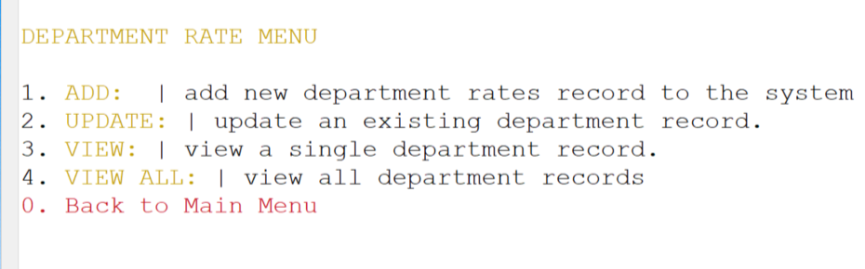

1. **Add:**
   * *Purpose:*
     + Add a new department with a unique code, name, and associated rates.
   * *Inputs:*
     + New department code (unique).
     + Department name.
     + Regular and overtime rates.
   * *Outputs:*
     + Display: Saved details or notification if the code already exists.
2. **Update:**
   * *Purpose:*
     + Update the rates of a specific department.
   * *Inputs:*
     + Existing department code.
     + Updated name and rates.
   * *Outputs:*
     + Display: Updated details or return to the submenu.
3. **View:**
   * *Purpose:*
     + View the details of a specific department.
   * *Inputs:*
     + Specific department code.
   * *Outputs:*
     + Display: Department details. Return to the submenu.
4. **View All:**
   * *Purpose:*
     + View details of all saved departments.
   * *Outputs:*
     + Display: Table of all departments. Return to the submenu.
5. **Back to Main Menu:**
   * *Purpose:*

Return to the main menu.

# Employee Data Submenu:

1. **Add:**
   * *Purpose:*
     + Add a new employee with a unique ID and relevant details.
   * *Inputs:*
     + Employee ID
     + Name
     + Department Code
     + TRN
     + NIS
     + Position
     + Hours Worked
     + Date of Birth
     + Date of Hire
   * *Outputs:*
     + Display: Saved details or notification if the ID already exists.
2. **Update:**
   * *Purpose:*
     + Update details for a specific employee.
   * *Inputs: (Updated Details)*
     + Employee ID.
     + TRN
     + NIS
     + Name
     + Department Code
     + Position
     + Hours Worked
     + Date of Birth
     + Date Of Hire
   * *Outputs:*
     + Display: The updated details. Return to the submenu.
3. **View:**
   * *Purpose:*
     + View the details of a specific employee.
   * *Inputs:*
     + Specific employee ID.
   * *Outputs:*
     + Display: Employee details. Return to the submenu.
4. **View All:**
   * *Purpose:*
     + View details of all saved employees.
   * *Outputs:*
     + Display: List of all employees. Return to the submenu.
5. **Delete:**
   * *Purpose:*
     + Delete a specific employee account.
   * *Inputs:*
     + Employee ID.
   * *Outputs:*
     + Display: Associated account for confirmation. Record deleted.
6. **Back to Main Menu:**
   * *Purpose:*
     + Return to the main menu.

# Employee Payroll Submenu:

1. **Process Payroll:**
   * *Purpose:*
     + Calculate and store payroll based on existing department and employee details.
   * *Outputs:*
     + Display: Calculation and storage of payroll. Confirmation message. Return to the submenu.
2. **View Payroll:**
   * *Purpose:*
     + View cheque details of a specific employee.
   * *Inputs:*
     + Specific employee ID.
   * *Outputs:*
     + Display: Cheque details. Return to the submenu.
3. **View Department Payroll:**
   * *Purpose:*
     + View cheque details for all employees in a specific department.
   * *Inputs:*
     + Specific department code.
   * *Outputs:*
     + Display: Cheque details for all employees in the department. Return to the submenu.
4. **Back to Main Menu:**
   * *Purpose:*
     + Return to the main menu.